FLIGHT BOOKING SYSTEM

Created By : Yash Dwivedi
Enroll No : 161B277
Batch : B-9
Email : dyash.3111997@gmail.com

1.First Screen

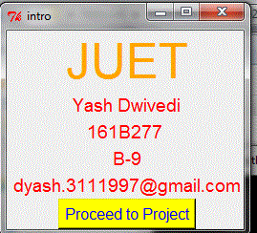

The first Screen show the Introduction of Student .

2.Second Screen

In Second Screen we have to Choose Source point and
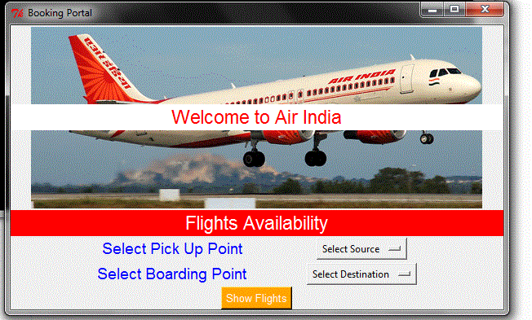
destination point using "select Source " button and "Select
Destination " button.

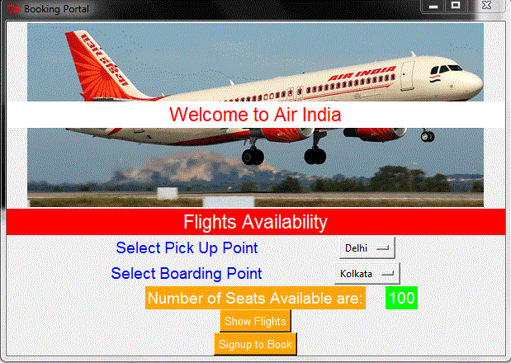
2.Second Screen

After selecting source and destination we click on "Show Flights" button and it display Number of seat available
at that particular route and a button saying "Signup to Book"
,this button take you to next window where you have to create a account to sign in.

3. Third Screen

After Clicking on "Signup to Book" button you reaches to a screen of signing up.Enter your Crediential there.

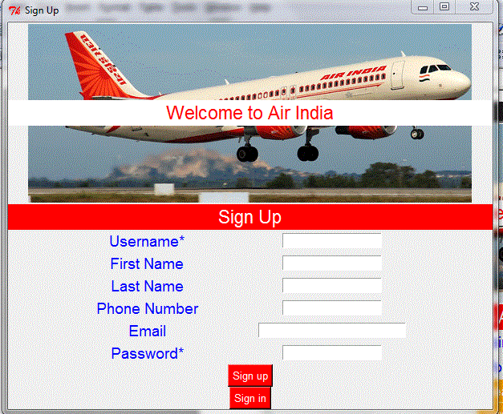
After Entering entries click on sign up. After clicking on sign up butoon ,a message appears saying you are signed up successfully .After that click on "Sign in".

After Entering entries click on sign up. After clicking on sign up butoon ,a message appears saying you are signed up successfully .After that click on "Sign in".

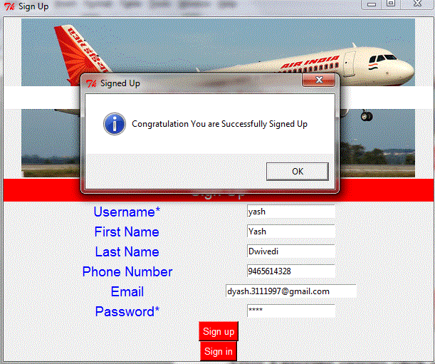

4.Fourth Screen

Enter your Credential here. After entering Credential click on
"Sign In", after clicking on Sign In ,this button take you to
next window where your basic data for ticket in entered.

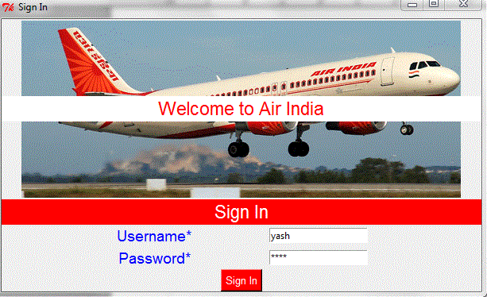

5. Fifth Screen
Fifth Screen contains your basic data for ticket.You should enter your name age and class in which you want to travel and also enter other passenger details.

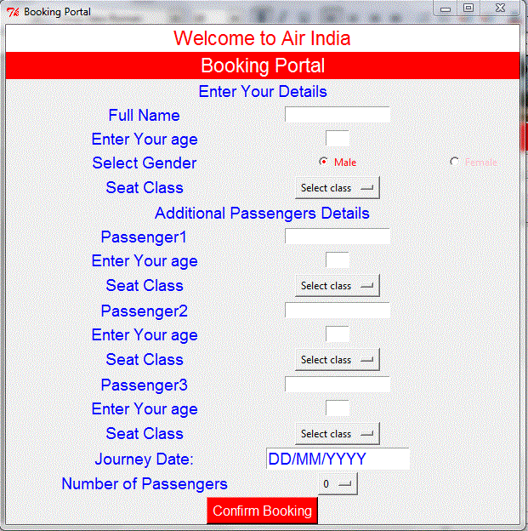

5.Fifth Screen
Enter your Credentilas and don't Forget to
Select no of passengers travelling along with
you.
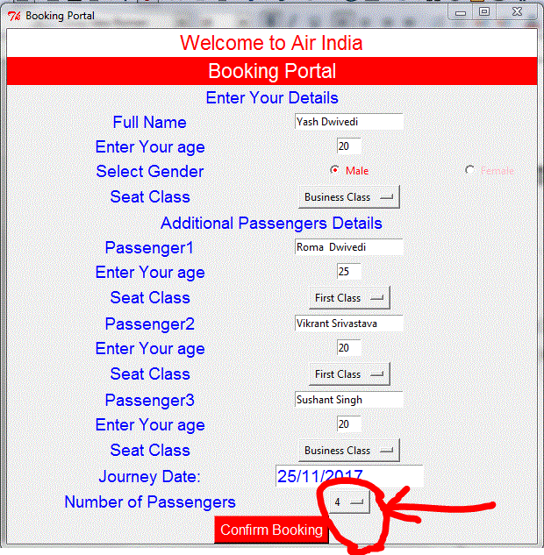

6.Sixth Screen
After entering Credentials Click on Confirm Booking and a
ticket will be "Displayed" on Screen where all your details
present.
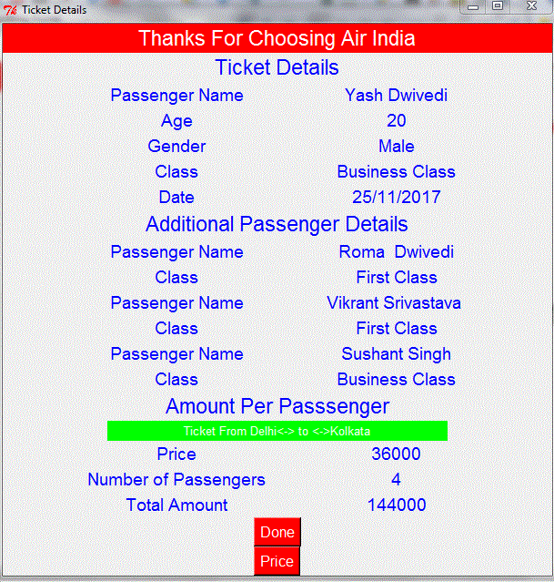



Thank You.

